**Capstone final Report**

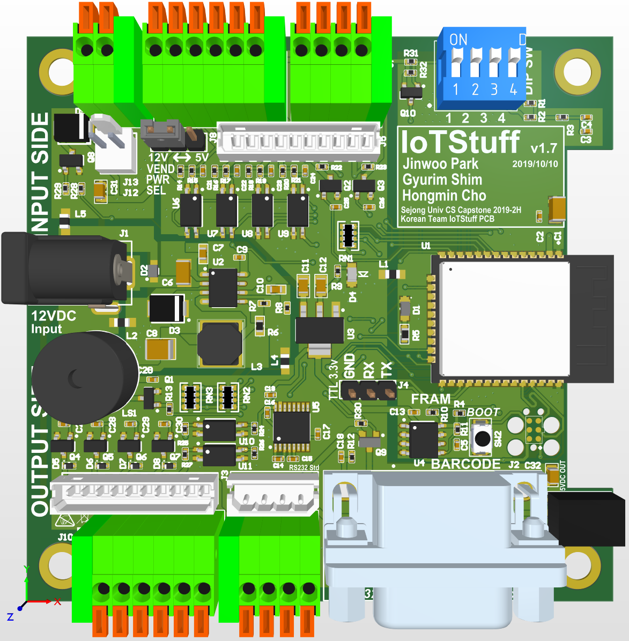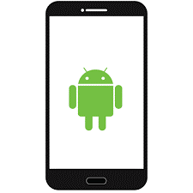

**Project Name : IoTStuff**

**14011058 Jinwoo Park**

**14011080 Gyurim Shim**

**15010990 Hongmin Cho**

**Introduction**

These days most of the traditional electronics and machine infrastructure are moving to internet. This is a.k.a “Internet of Things” But most of current product is still hang on not-friendly with price , customizable and compatibility . This is one of semi-industrial hw-based with simple in/out system and connected to bluetooth and Wifi for communicate for get or set each node’s I/O(Input / Output) control. Since there are limitation of h/w develop but we tried maximized our h.w consideration as we can.

**Motivation**

As I said, There’s limitation for current marketplace , “Not-Friendly price” , “Customizable” and “Compatibility”. Many manufacture are trying to fit compatibility with several ways like these product.

|  |  |
| --- | --- |
|  | **Xiaomi Universal IR Remote Controller**  This device connected to server with Wifi and device make gateway for IRDA based device.  (TV and Air-condition etc)  # Limited to IRDA and IRDA Protocol is tricky. |
|  | Samsung Smartthing Platform  This is not device, it’s platform, this platform connect latest samsung electronics with Wi-Fi and make whole system as Home Automation.  # Limited to their brand electronics |
|  | Homekit  Open API for IoT system. It’s like push alert system for apple device. Many sensor and IoT device can connect to Apple HomKit.  # Free usage to device (node) But controller is limited to control them by only apple device. |

But still there are lack of customizable and not-friendly price and if there’s one more consideration. It is ease of customizable. Some of product support “Customizable function” as SDK but it’s still tricky and limited to engineer and programmer , or least tool-kid.

Our Ultimate Goal

Our ultimate goal is center of this diagram that correspond these three things. For close to this goal this is consideration.

1. Wide range of voltage should be accepted for input and output.
2. Full fill #1, I/O system should be safety circuit.
3. Terminal of input and output should be easy to use.
4. Wireless system should be going long and keep stable.
5. Systems should be controlled by Sub-Device (Phone or Server).
6. Price should be cheap even M.O.Q is low.

These pre-consideration weren’t full-filled perfectly. But we guess it’s very closed to our goal.

**Role of each member**

14011058 Jinwoo Park (박진우) : H/W and Firmware Development , Team Leader

14011080 Gyurim Shim (심규림) : Communication system for Android App

15010990 Hongmin Cho(조홍민) : User Interface for Android App

**First and current Sketch of our project**

First we illustrated make Mesh topology with BLE Mesh between Phone and each device.

**About BLE Mesh**

BLE is Bluetooth Low Energy. It is more complex than general Bluetooth. It needs provisioning for connect device to network. Net key, and App key needs for security. Furthermore, when we using similar app (that has BLE function) connected to ESP but it connected unstably.

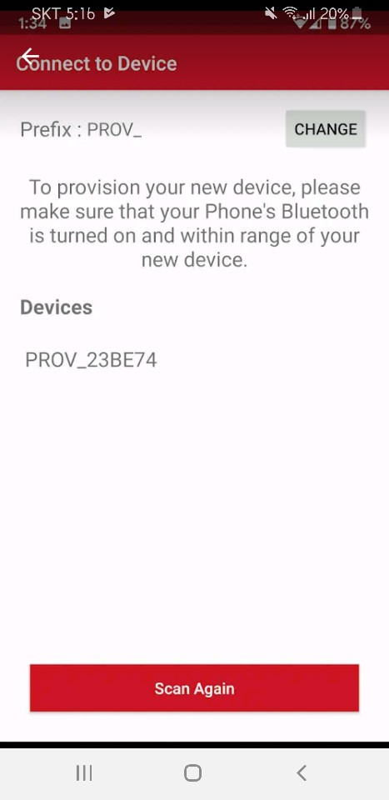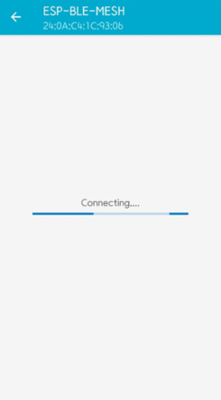

<Similar apps that have BLE function>

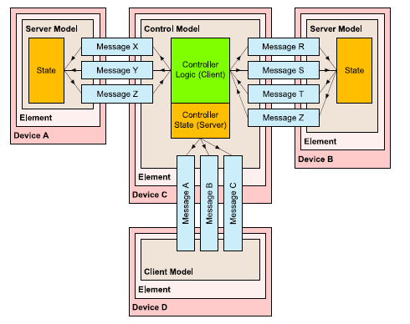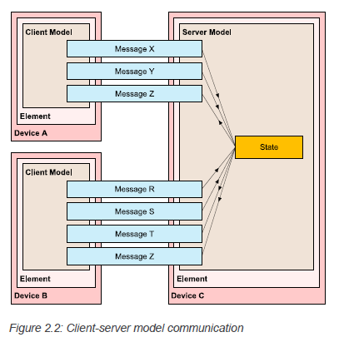

**Model: define basic functionality of a node.**

* 1. Server-model: composed of one or more states. Defines set of messages.
  2. Client-model: defines set of messages that client uses to request.
  3. Control-model: contain client model functionality to communicate with other server models or vice versa.

**Address Notion**

1. Unicast address: unique address allocated to each element.
2. Virtual address: set of dest address
3. Group address: Programmed into zero or more address.

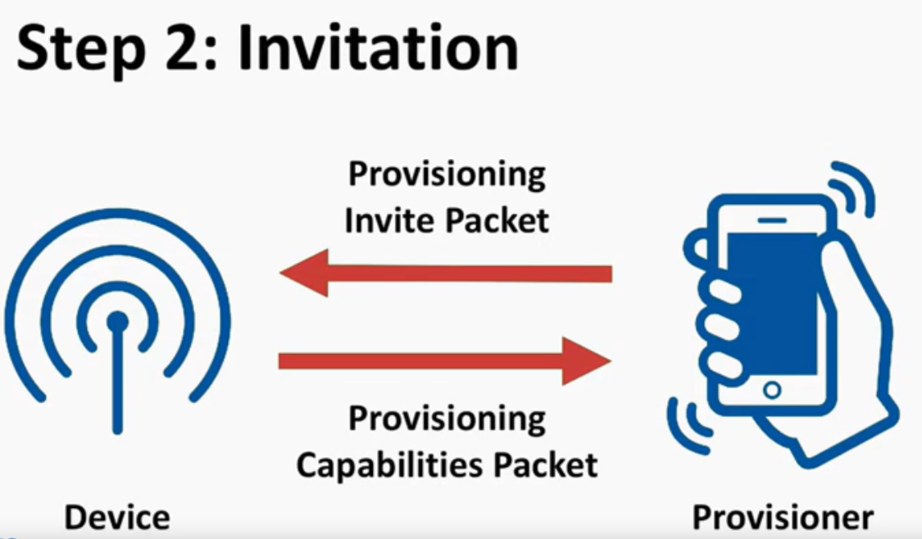 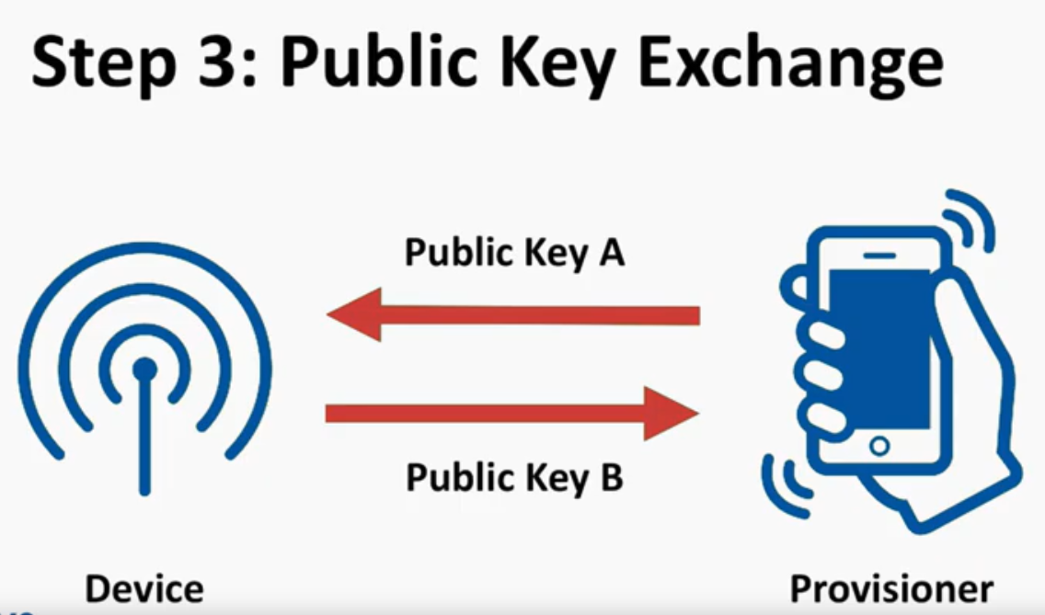

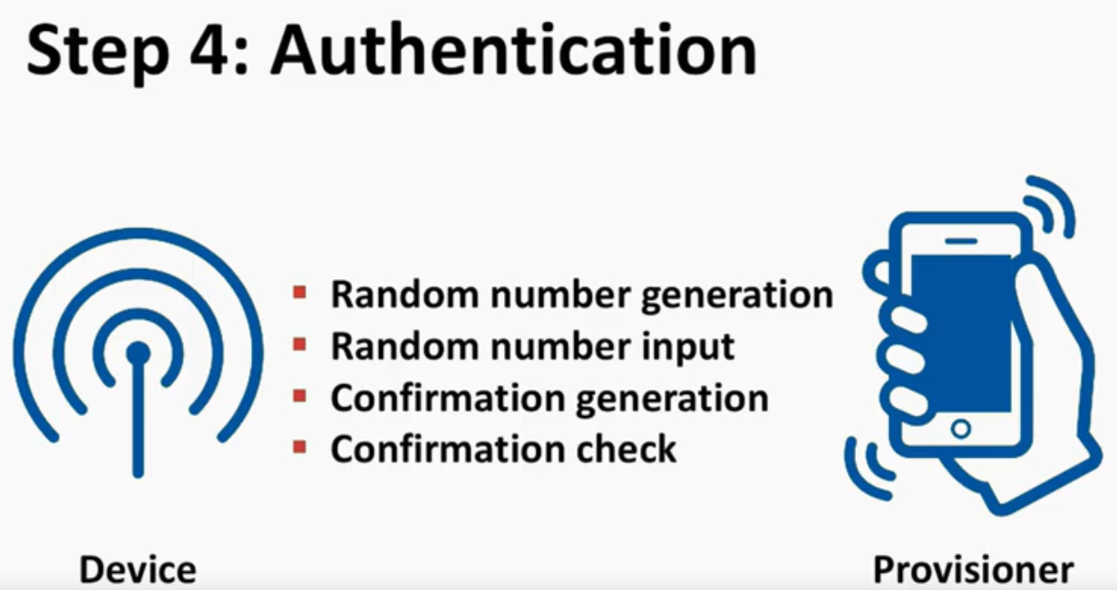 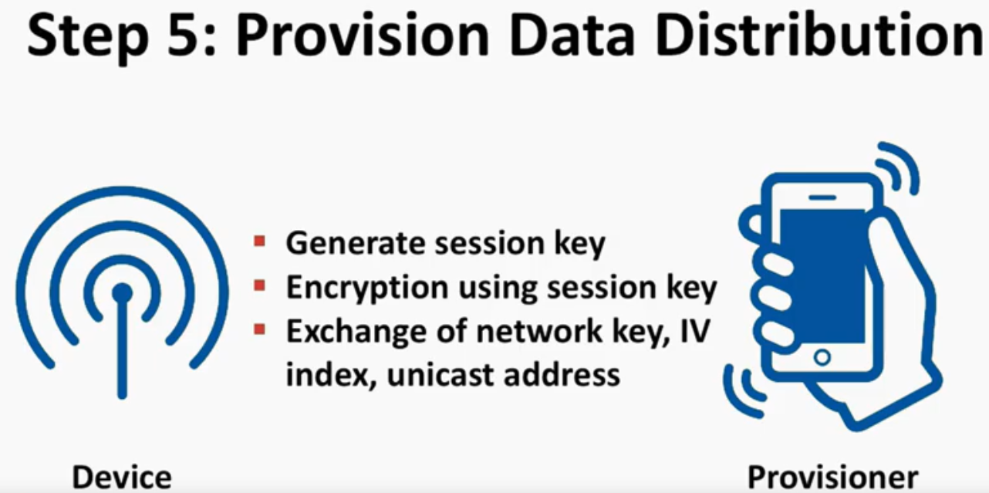

**Provisioning process**

1)beaconing: device send out beacon advertisement. It triggered by button press.

2)invitation: provisioner provisioning invite packet.

Device Provisioning capabilities packet.

3)Public Key Change:

4)Authentication: authentication by generating random numbers.

5)Provision Data Distribution: they exchange of net key, IV index, unicast address.

|  |  |
| --- | --- |
|  | 1. Bluetooth Low energy layer    * On top of BLE(requires full BLE stack)    * Utilize the advertising feature    * Support GATT for proxy nodes. 2. Bearer Layer: defines how mesh packets(PDU) are handled.    * Advertising bearer: advertising and scanning.    * GATT bearer: help non-mesh device with the network. 3. Lower transport layer: segmentation of packets from layer above.(upper layer)    * Reassembly of packets from layer below(bearer layer) 4. Upper transportation layer:    * Responsible for :encryption, decryption, authentication, transport control messages (heartbeat, friendship) 5. Access layer: defines how application uses the upper transport layer. 6. Foundation layer: concerned with net config and manage model. 7. Models layer: behavior, messages, states |

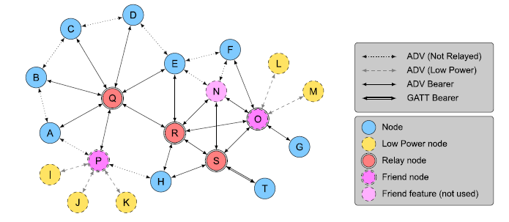

Species of BLE Nodes

* **Friend nodes : it help low power nodes that they collect info in cache instead of low power nodes.**
* **There are 4 features.**

**Relay/Proxy/Friend/Low power features.**

* **Two mesh bearers:**

**advertising bearer/GATT bearer**

* **All messages are encrypted and authenticated using two types of keys.**
  1. Network layer communication. All nodes use the same network key.
  2. Another key is application data.
  3. These allows sensitive access messages to be separated from non-sensitive access messages.

Also, these secures safe relay transmission.

**Moved to New structure for communication system**

But as we said there’s limitation of android development. For iOS BLE Mesh is very working well. But each android phone manufacture doesn’t support BLE Mesh well. For the result, Bluetooth Chip Manufacture’s BLE Mesh test application doesn’t working well on several android device (Nordic Semiconductor and EFM).

|  |
| --- |
| **IoTStuff Firmware**    **bootloader**  **ESP-IDF**  **[ WiFi/BT Coexistence Stack ]**  **BLE Mesh Acceptor**  **GPIO Event Machine**  Previous Structure. |

After meets this issue. We need to change all of structure to possible structure. There were lots of solution we selected. After some survey we changed to like this (below picture)

|  |
| --- |
| Current structure |

Classic BT SPP for connect with android , and Wifi for connect with each nodes. And special thing is Wi-Fi and Bluetooth classic is working together with one 2.4Ghz RF Engine.

This tech is called as “WiFi / BT Coexistence”

**Develop of android communication**

|  |  |  |  |
| --- | --- | --- | --- |
|  | |  | Before ESP32 device arrived, we tested Bluetooth with the other smartphone. We implemented radio buttons that represents input and output, when click these, then the information is sent to the other smartphone.  (left : Paired Device List)  (Right : Discover New Device) |
|  |  | | We implemented internal DB for saving logs. So after we terminate the app, we also can load past logs.  (left : Client)  (Right : Server) |

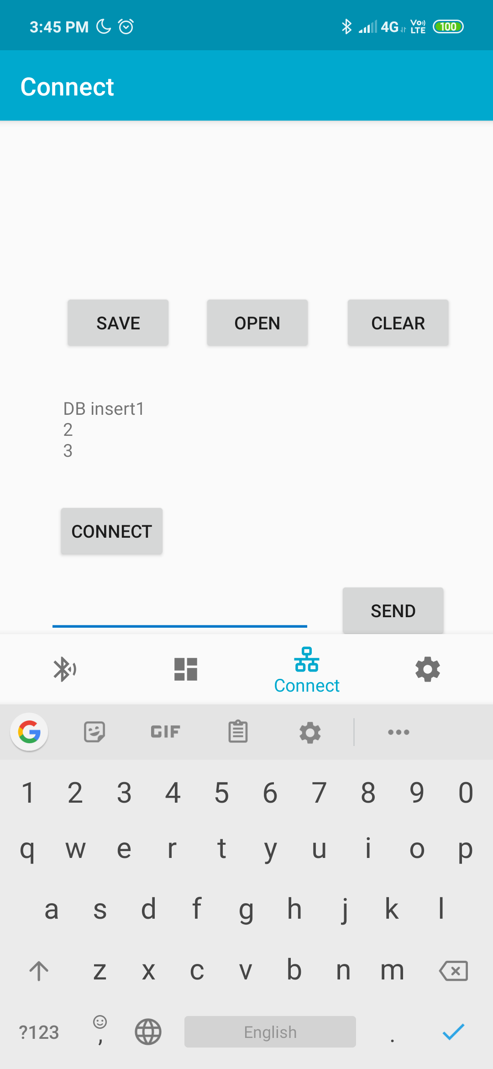

Log saving at internal DB

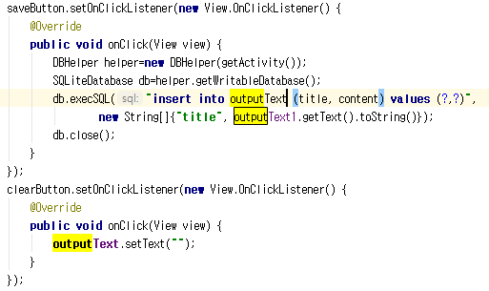

Using queries load logs

Operation Sequence

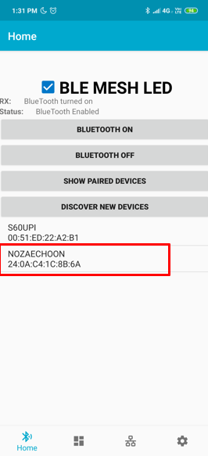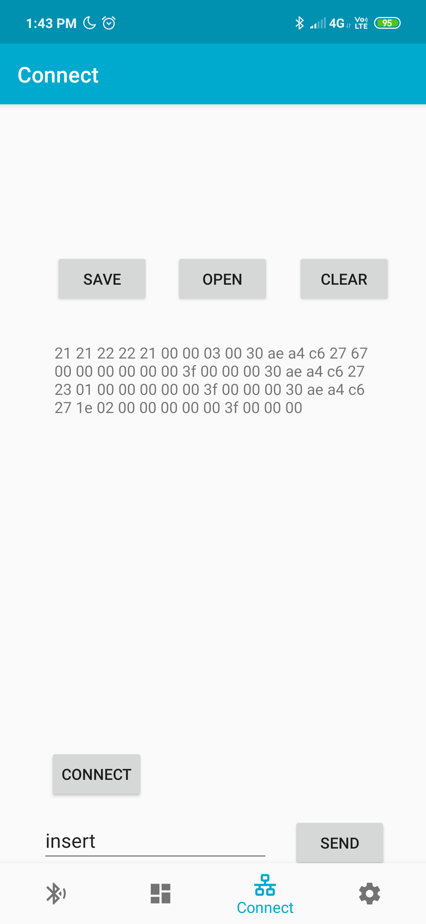

Click the device Press connect button

We can connect ESP device click “show paired devices” or “discover new devices”

Then at the connect tap, we can communicate and receive profile from the ESP device.

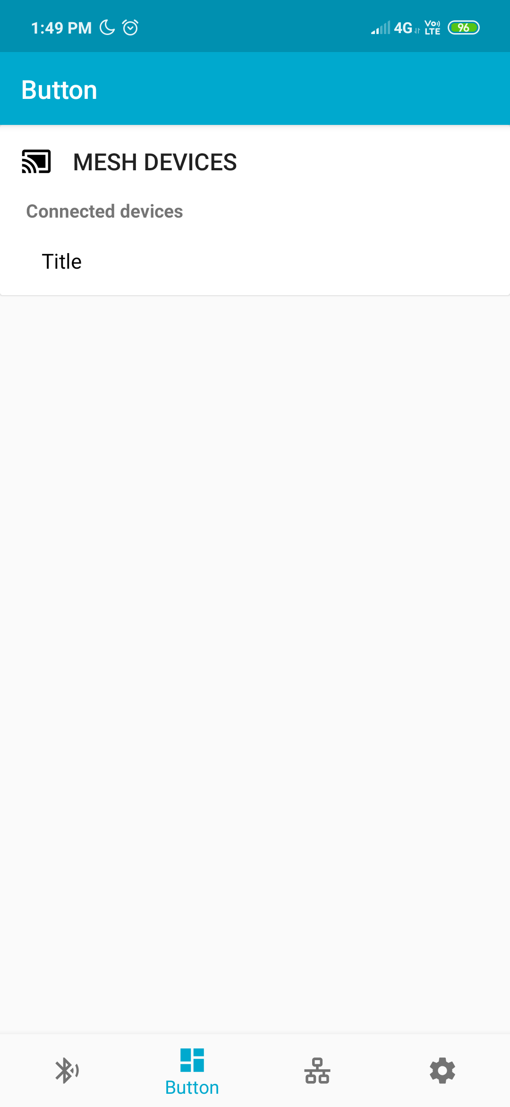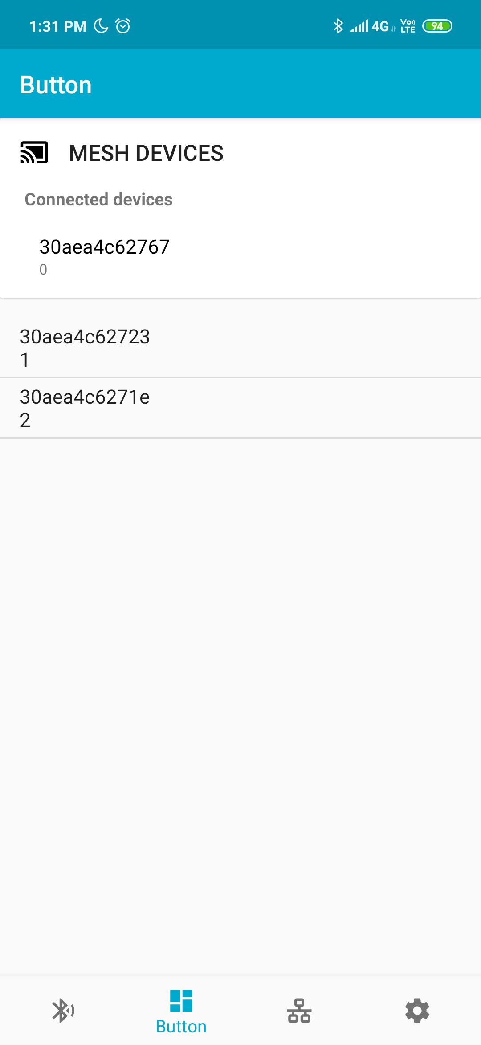

Not connected After get profile

Transmission process to ESP

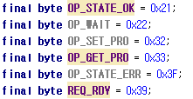

instructions between ESP and android

* OP_STATE_OK recognizing other device’s condition.
* OP_WAIT means current device is busy, so cannot process other function now.
* OP_SET_PRO is set profile(Packet Data or Packet State), OP_GET_PRO is opposite one.
* OP_STATE_ERR mean error occurs on current device.
* REQ_RDY means current device is ready for process.

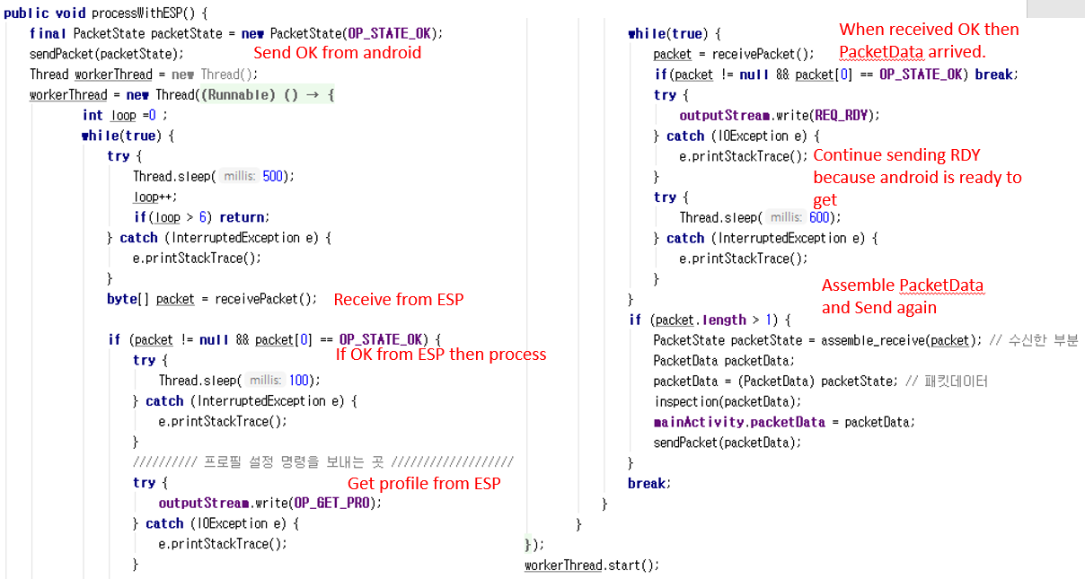

Android device send OK => ESP ack => Android send “get profile” => ESP send profile

=>Android valid check(whether first byte is OK) & receive Packet Data or State(if there just OK information) => Android send modified Profile(if changed, else send same thing)

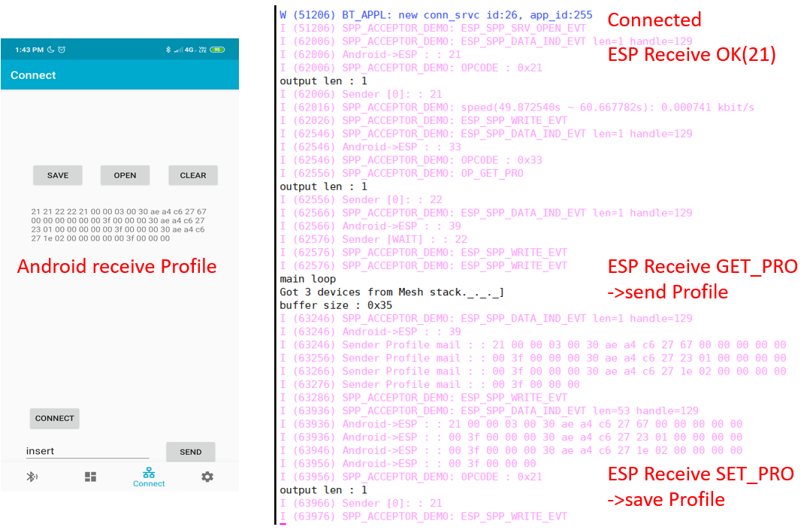

Android Screen Xshell screen connect to ESP32 (via USB)

On android screen, logs appear that is same as what it received.

On Xshell screen, ESP log appeared.

We can discover both screen logs value (Packet Data) are same.

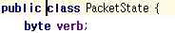 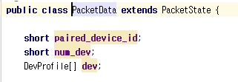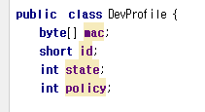

Packet State Packet Data Devprofile Class

Packet Data and Packet State are packet between Android device and ESP32.

It contains Profile of EPS devices in the network.

DevProfile is within PacketData.

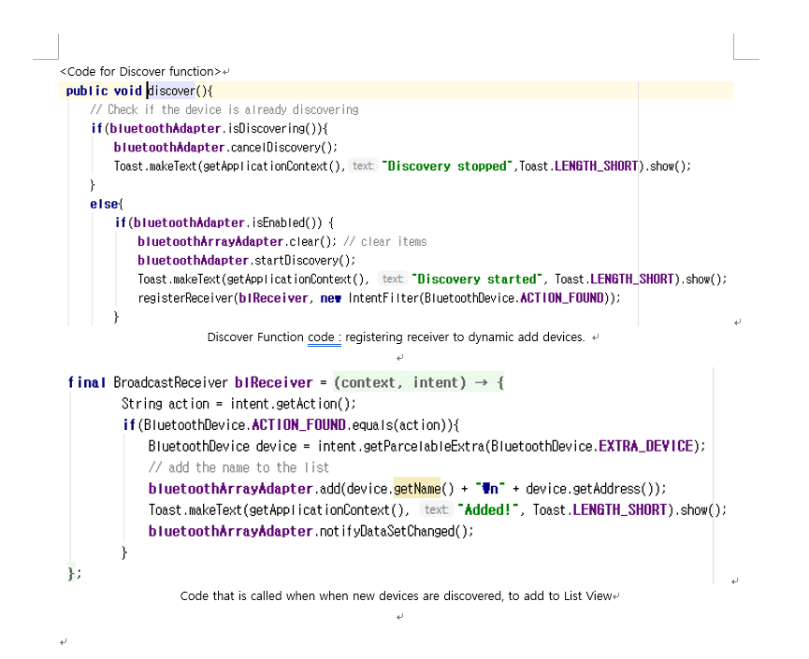

Trouble Shooting

<Using Git>

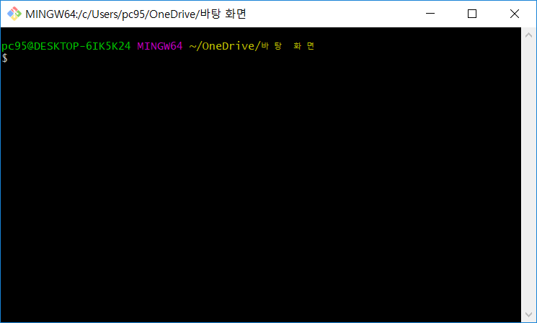

Git bash

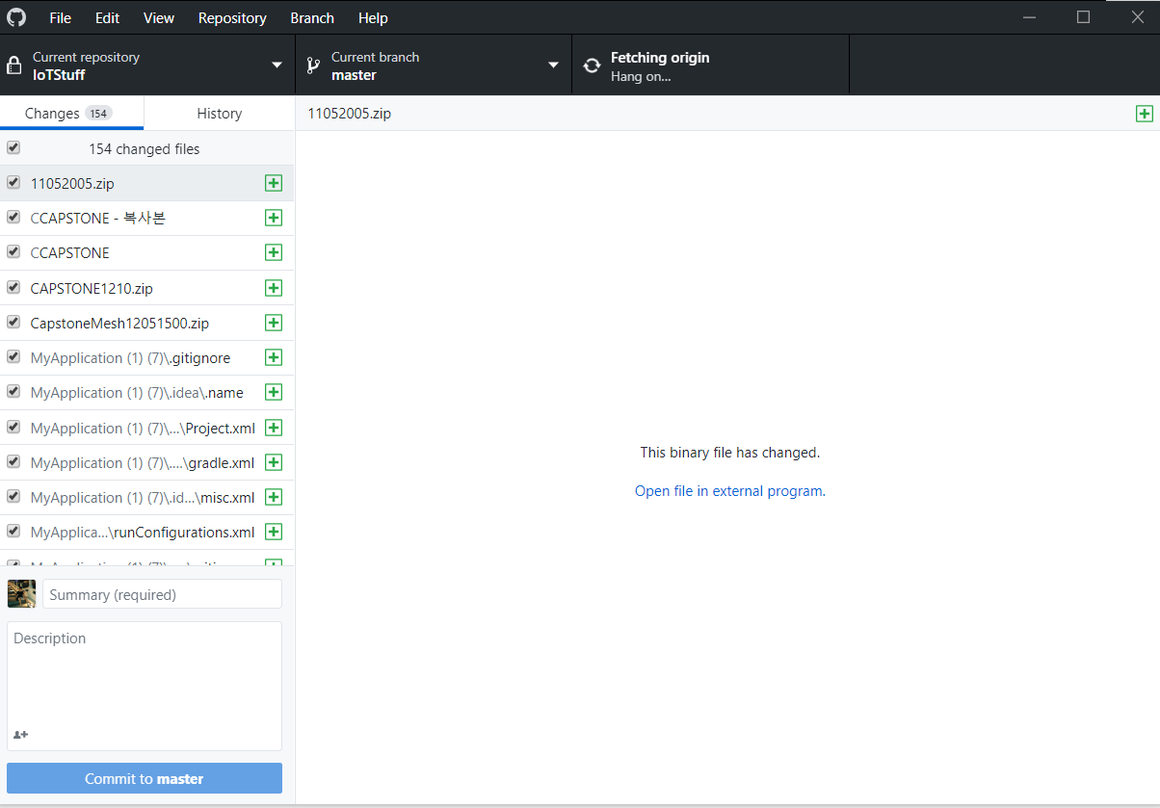

GitHub Desktop

For source code sharing, we wanted to use Git.

But Git bash is so difficult to use.

After we found that GitHub desktop is GUI and easier to use.

<Endian problem>

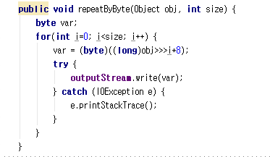 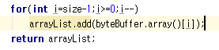

after applying big endian

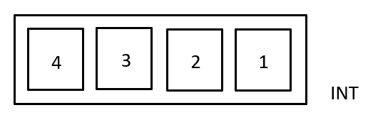

sequence of transmission of integer

Transmission between ESP and Android is using Big endian.

Each number on the upper image represents byte of integer.

Receive sequence is also same.

<Applying List View>

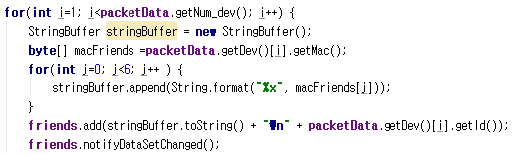

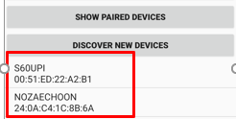

When we apply List View, it didn’t work. Because of there wasn’t notifyDataSetChanged.

<Synchronization Problem>

Before applying handler, appearing text is so unstable.

Handler adjusts between threads. So after apply it, it works stably.

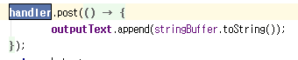

Handler

When we connect main activity and each fragment, we connected it by allocate variable of fragment in main activity.

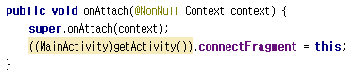

Allocate fragment at on Attach

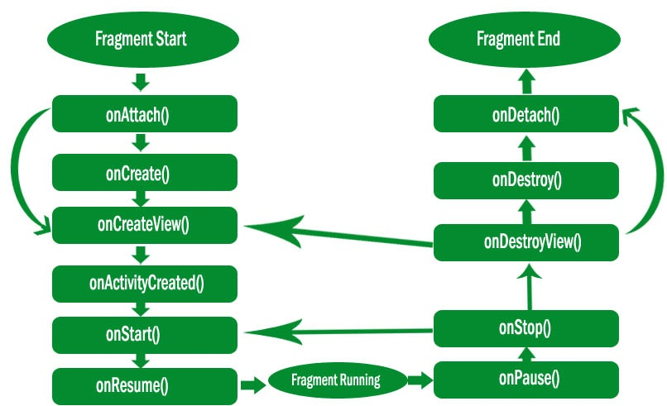

Fragment lifecycle of Android

When we did on Create error occurred.

But after we searched the lifecycle, we discover it must be on Attach.

**Android UI Development**

The Flow of our android app is working like this



**Application introduce**



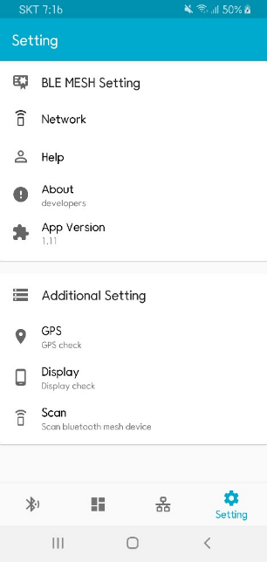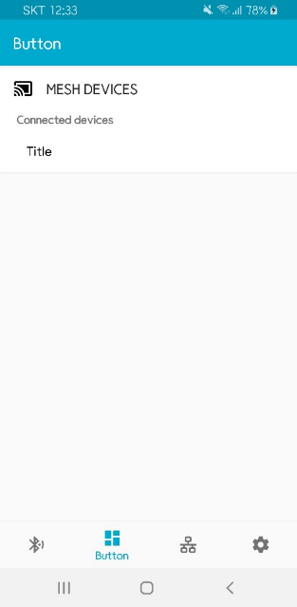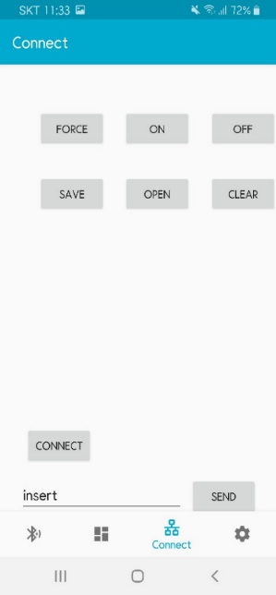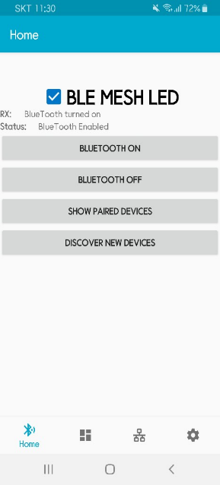

- Background color blue

- 4 Fragments

**Setting**

|  |  |
| --- | --- |
|  | **- Using card view, toolbar, include**  **- mesh setting**  Help(call), About(Developers), App Version(1.11)  **- additional setting**  GPS, Display, Scan(Bluetooth)  Go to the window inherent in the user's phone.  Using intent |

**The issue of Android UI development.**

|  |  |
| --- | --- |
|  | There was a problem with the dynamic design because the screens of the other team members' devices and my cell phone were different. |

HW Design

First we used Altium for circuit tool. And For debugging and assembly. We Used Oscilloscope and own soldering station. For ordering we used JLCPCB.com (chinese). They offer cheap SMT with PCB fabrication.

Hardware development Notes

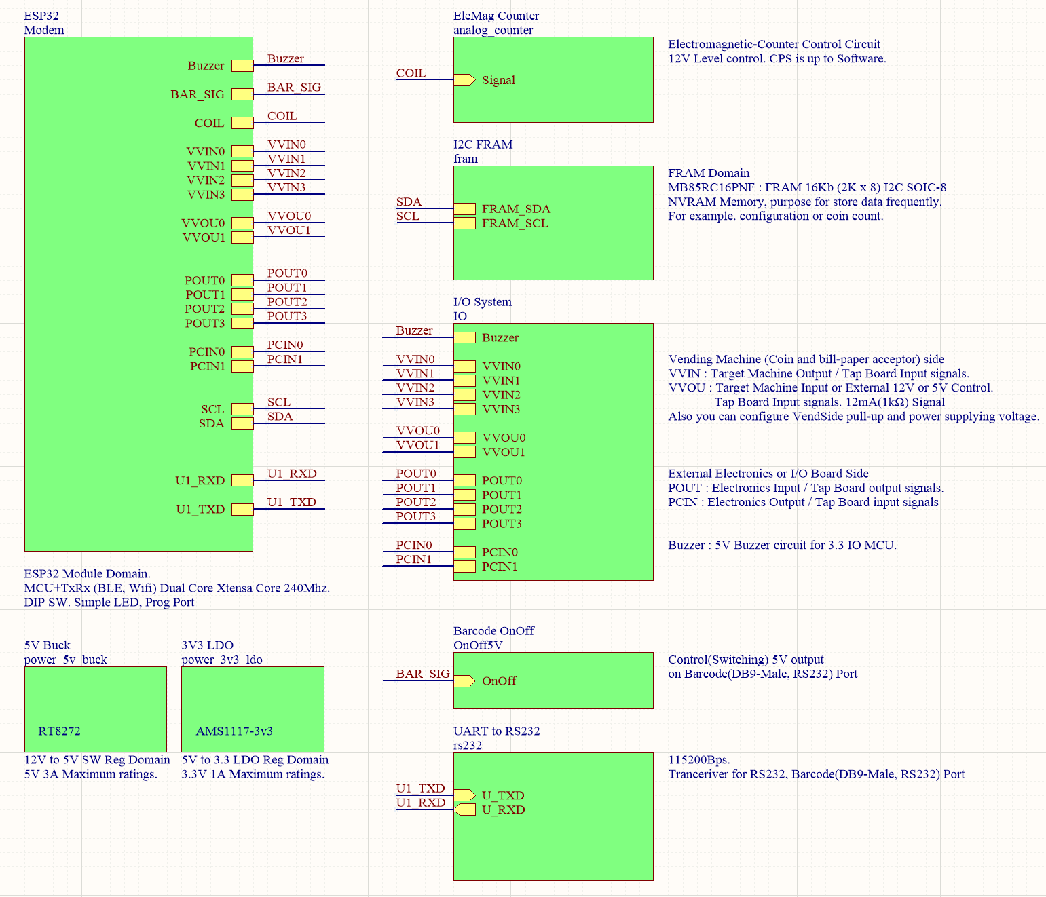

Main root of each schematic domains.

As I already mentioned at initial of this documents. Below 6 items are considered on our project.

HW consideration for this develop.

|  |
| --- |
| 1. Wide range of voltage should be accepted for input and output.  2. Full fill #1, I/O system should be safety circuit.  3. Terminal of input and output should be easy to use.  4. Wireless system should be going long and keep stable.  5. Systems should be controlled by Sub-Device (Phone or Server).  6. Price should be cheap even M.O.Q is low. |

|  |
| --- |
| Safety Output system |
| 1. Wide range of voltage should be accepted for input and output.  2. Full fill #1, I/O system should be safety circuit. |

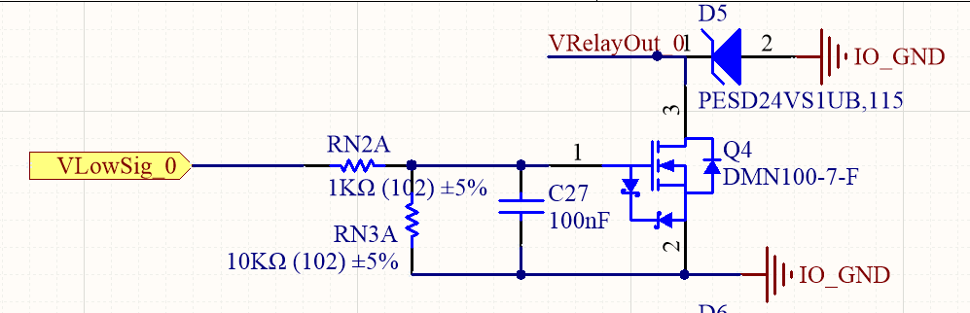

<VrelayOut_n is Net Name for external output port , VlowSig is output order signal from MCU>

ULN2003AIDR has some issue COM line is shared. so we didn't used for separate voltage (For example if Terminal 1 is connected system with 12V level with pull-up and terminal 2 is connected to 5V level with pull-up, they are getting break) Q4:7 was changed to PMV100ENEA from IRFL014PBF. Because IRFL014PBF was obsoleted. Btw JLCPCB Assembly service don't have stock or option for PMV100. So DMN100 and PESD__ is alternation for this assembly system. At the result this system is close to ground or not for external pull-up (12V ~ 3.3v, Maximum rating is near 17V).

|  |
| --- |
| Safety Input system |
| 1. Wide range of voltage should be accepted for input and output.  2. Full fill #1, I/O system should be safety circuit. |

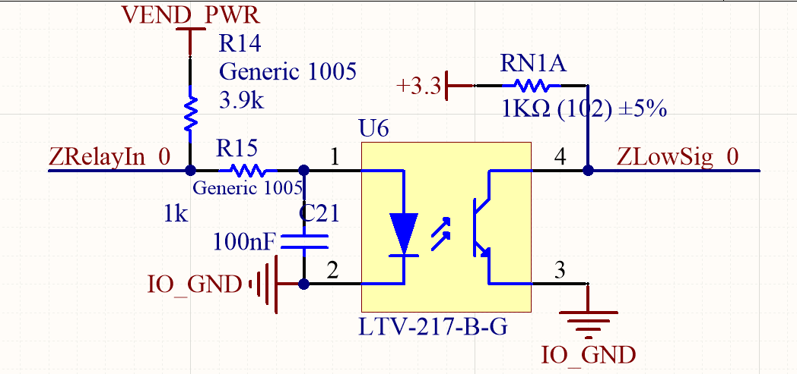

<ZrelayIn_ is input terminal , ZlowSig_ is input Net to MCU side>

For getting 5V or 12V input we used Photo coupler (LTV-217) on input side. It isolate input and output with LED and photon-Transistor so it’s very safe from wide-range of voltage input.

|  |
| --- |
| Easy Terminal |
| * 1. Terminal of input and output should be easy to use. |

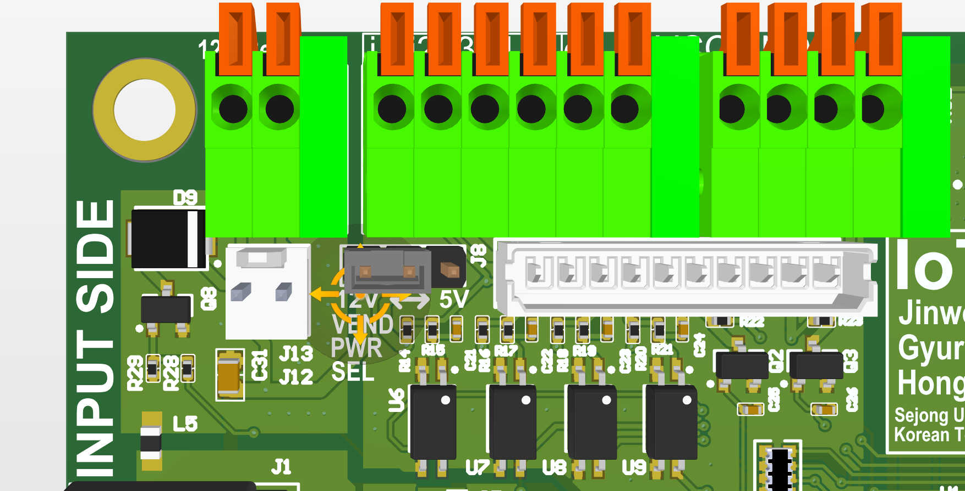

We used Terminal Block with push slide for don’t need to make cable and clamp for each installation.

|  |
| --- |
| RF+MCU Chip Module : ESP32-WROOM-32D |
| 4. Terminal of input and output should be easy to use.  5. Systems should be controlled by Sub-Device (Phone or Server). |

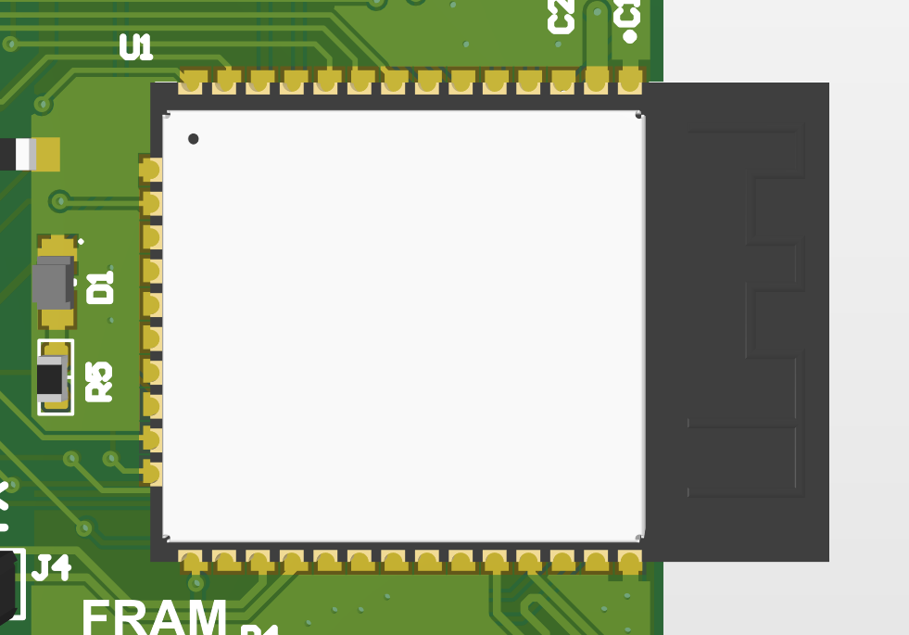

By using dual core MCU with WIFI-BT. Smartphone can control this chip and it contains internal antenna. So we don’t need care about antenna design.

|  |
| --- |
| Cheap Price to end user |
| 6. Price should be cheap even M.O.Q is low. |

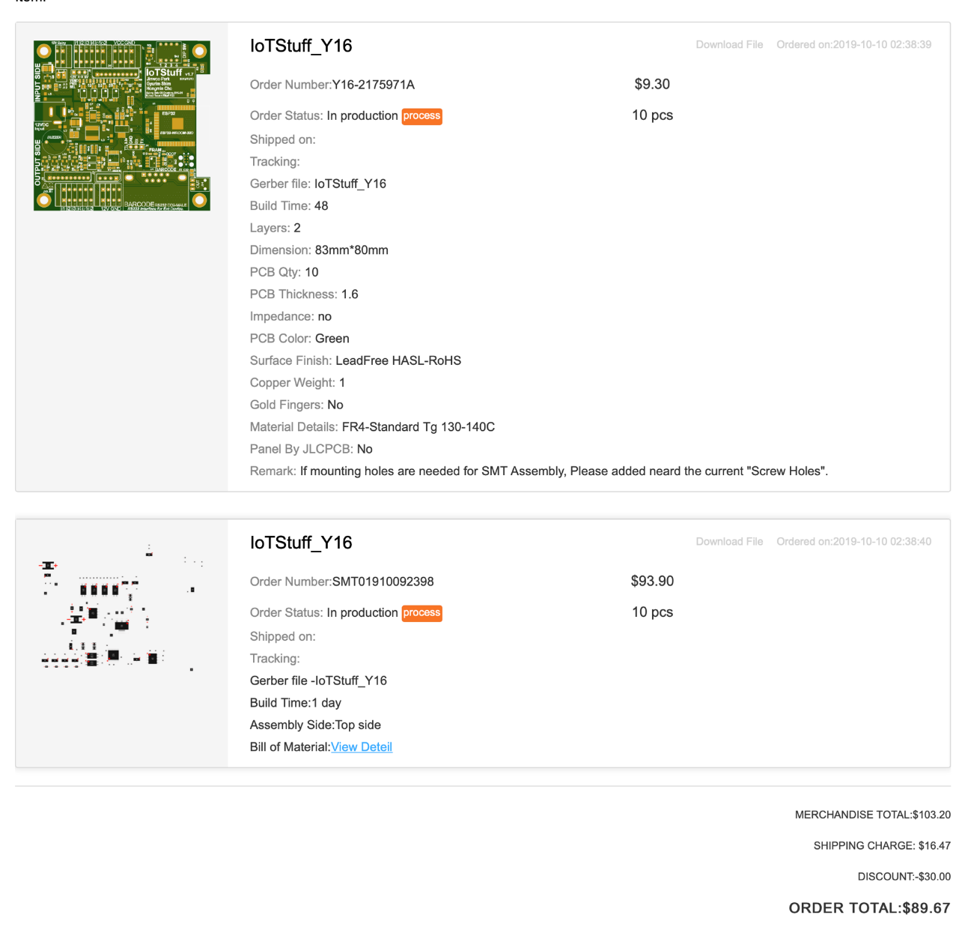

89 USD for 10 PCB

With Semi assemblied.

Remain components

* MCU Module
* Ports
* Tact Switch

**Semi-Assembled PCB and Full-Assembled PCB.**

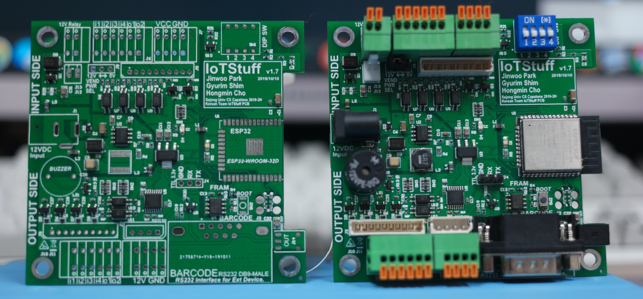

**Pick and Place Issue**

PCB’s Assembly data should be fix for each factory. Because Pick and Place is “How assembly parts” and robot arm rotate parts for pick and place on PCB. But PCB designer’s rotation rule and factory’s rule is different.

This is tricky issue. So I made script for fix it automatically with manual user own rule.

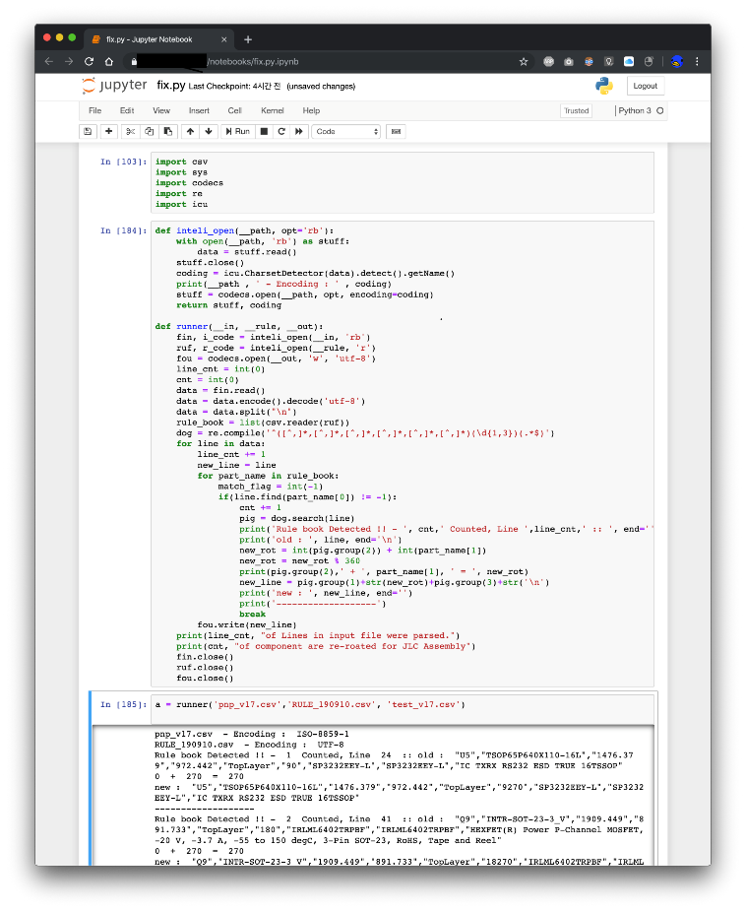

**Firmware Programming**

Programming with FreeRTOS (Branch of xtensa core) and limited standard library C99

ESP32 is working with 240Mhz xtensa dual core.  
RTOS create task and scheduling very well. But need to use multi-core aware lock system for each process communication

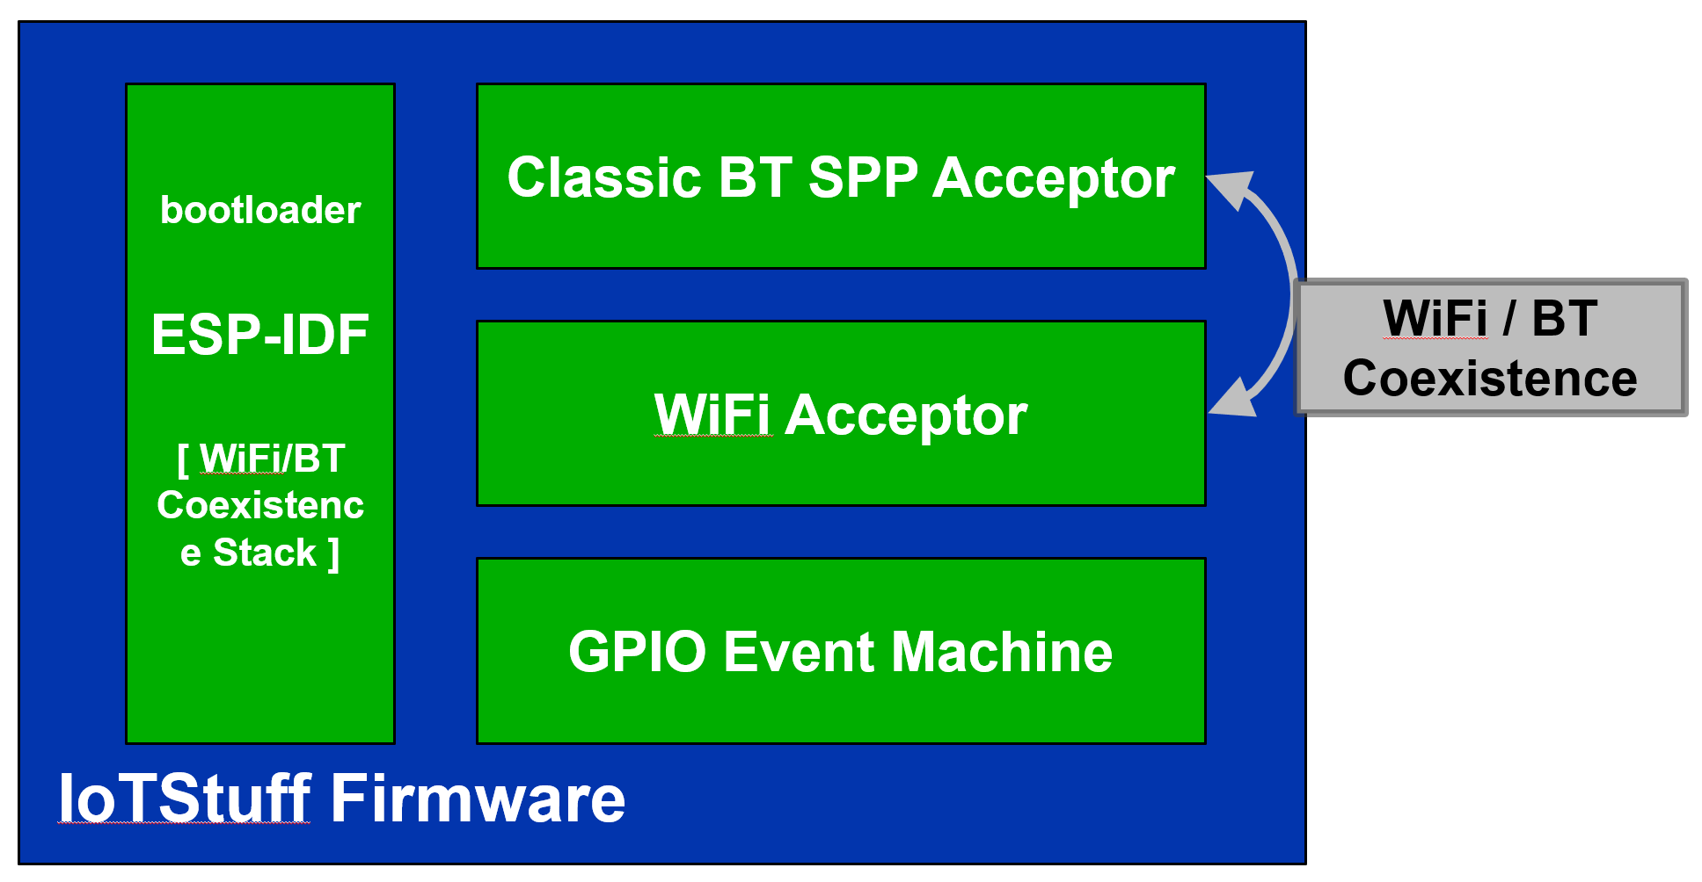

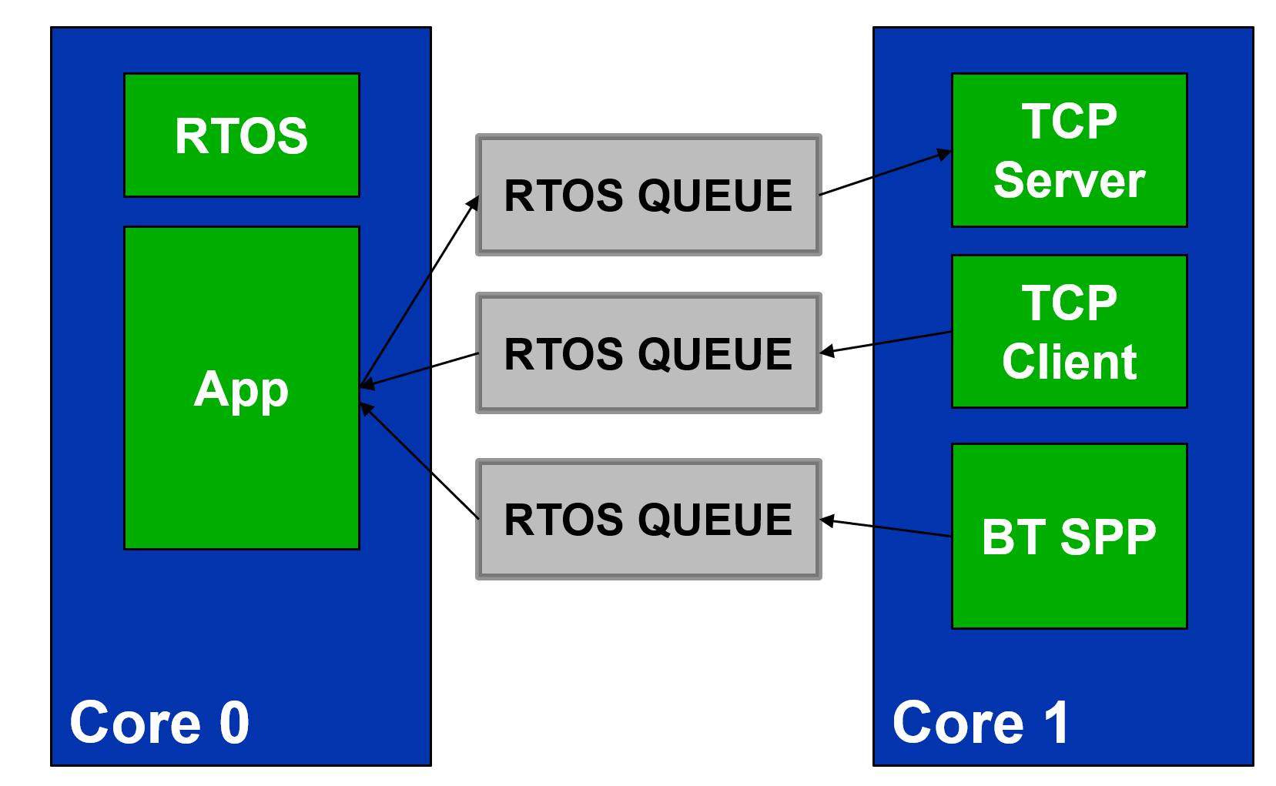

* Each process communicate with queue system with queue.
* Each task watch queue, if there’s new item. Do process.
* ESP32 have 520Kybtes SRAM. Much more SRAM than any MCU.  
  This make this simple queue system with many task.

**Result** 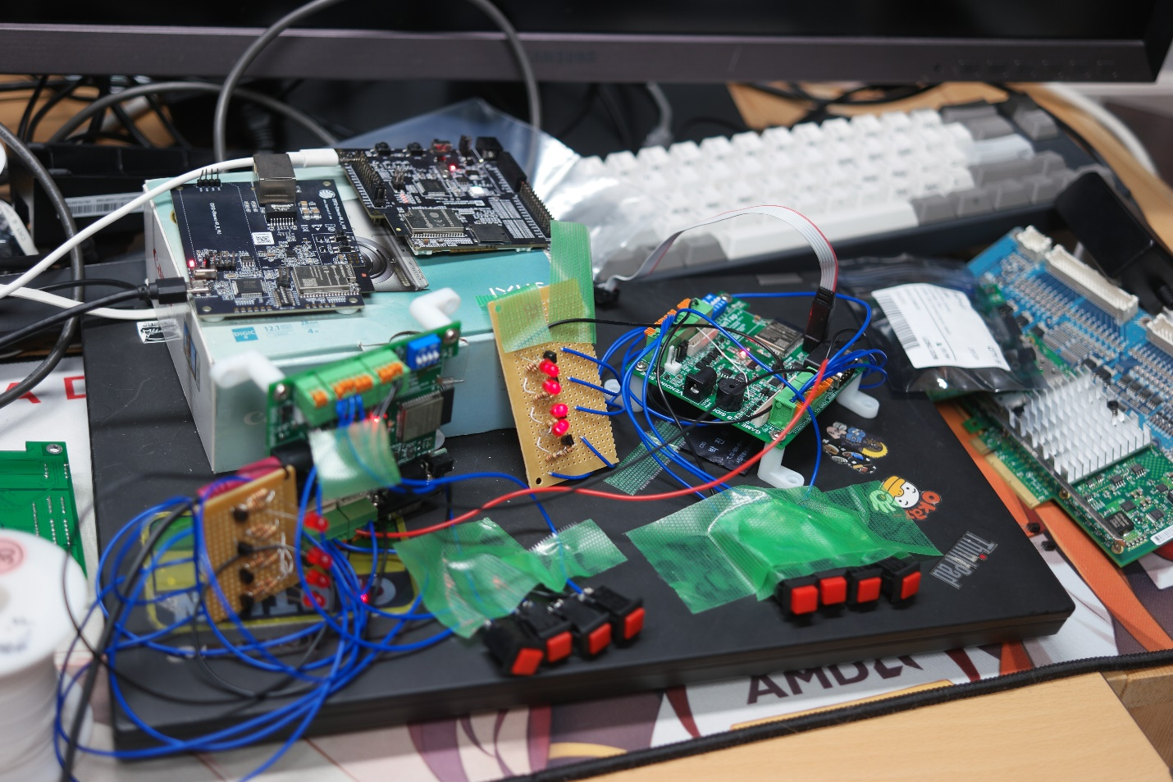

At the result. Home demonstration was worked. But After taking to university that weren’t worked well.

After took the system and analyze them we found some issue.

If there’s lots of Wi-Fi router (many channels are already using). The Problem is WIFI/BT Coexistence is getting trouble. And then result TCP server getting some bad packets some times. For overcome this TCP server should catch those failure packets but we didn’t care about this issue.

We think most big problem we couldn’t fix this is barebone embedded system with RF is very difficult then other communication system develop on PC with operation system. We are using RF Coexistence and already changed from BLE Mesh. So there were few time to try trouble shooting communication systems.

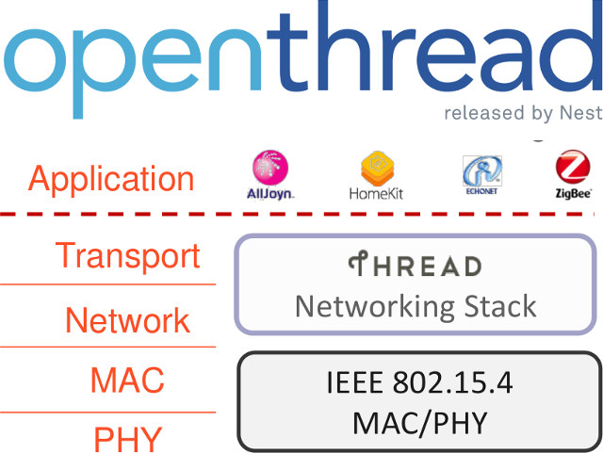**If we develop this again…**

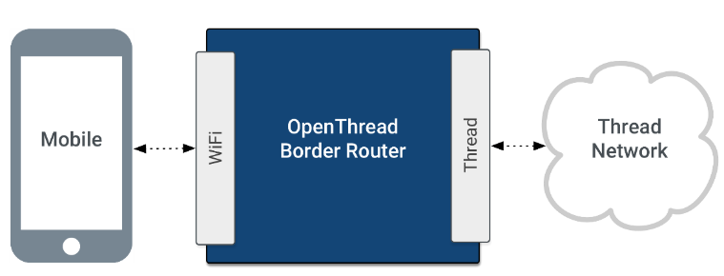

We’ll not using BT-SPP + WIFI. Coexistence is very difficult. After some survey google open thread RF tech is very good for mesh system and IoT

<https://www.silabs.com/documents/public/application-notes/an1142-mesh-network-performance-comparison.pdf>

According to this survey note from “Silicon Labs” their research say for Mesh network openThread has minimum transmission latency and mesh hopping latency. But current ESP32 chip doesn’t support so for using this we need to change to nrf52832 or nrf52840. First time I considered to using them but their module is 3 times more expensive so I didn’t selected. But for now I wanna using them.

After this project. Embedded system is very difficult to build up. No way to redo design again. But this was good experience to challenge with RF and Android and team-project.

Thanks.